Practicum Case | 
COMP6885 | COMP6885001
Natural Language Processing
Computer Science | O251-COMP6885-FA01-01
Valid on Odd Semester Year 2024/2025 | Revision 00

Learning Outcomes
- LO1 - describe what is Natural Language Processing and its components
- LO2 - explain Explain fundamental concepts of how to work with Natural Language Processing

Topic
- Session 01 – Introduction to Natural Language Toolkit (NLTK)

Sub Topics
- Corpora
- Tokenizing
- Removing Stopwords

Soal
Case
NLTK Processor

NLTK Processor is an application that is used to process sentence(s) input by user. You as programmer are asked to build the program. There are some requirements that must be fulfilled:
- For the first time, the program will ask the user to input sentence(s). Validate the input must not be empty
- Then, the program will show the tokenized sentences

- After that, the program will show the tokenized words
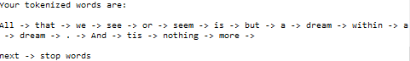
- Next, the program will show the stop words


- Then, the program will show the stemmed words
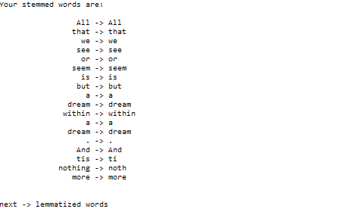
- After that, the program will show the lemmatized words
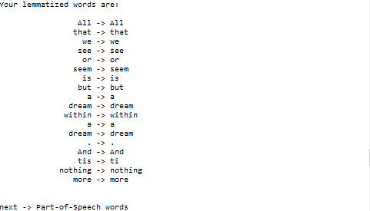

- Then, the program will show the part-of-speech words
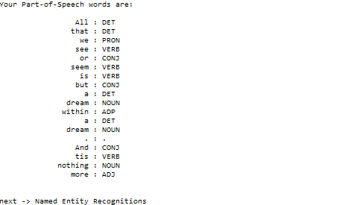
- Next, the program will show the named entity recognitions
- After that, the program will show the frequency distributions
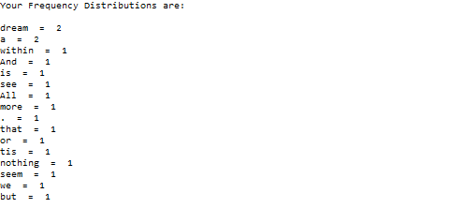

- Finally, the program will exit

Please run the EXE file to see the sample program.

